**Experiment No.1 Date:14/09/2021**

**Make Circuits on Breadboard**

**Aim:**

To learn to make circuits on breadboard on [www.tinkercad.com](http://www.tinkercad.com)

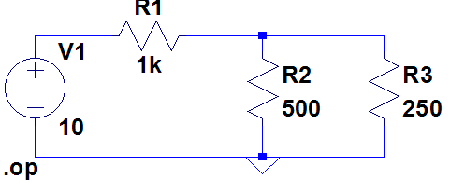

**Observation:**

**Voltage and Current Measurements**

|  |  |  |
| --- | --- | --- |
| **S.No** | **Parameter to be measured** | **Value Measured with Units** |
| 1 | Voltage across R1 | 8.57 V |
| 2 | Voltage across R2 | 1.43 V |
| 3 | Voltage across R3 | 1.43 V |
| 4 | Current through R1 | 8.57 mA |
| 5 | Current through R2 | 2.86 mA |
| 6 | Current through R3 | 5.71 mA |

**Sharable link of the Simulation**

**Screenshot of Simulation done in TinkerCAD**

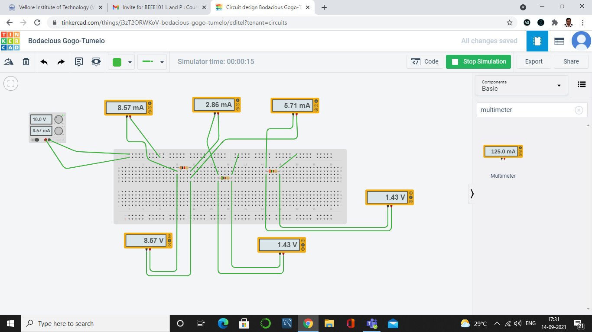

**RESISTOR COLOUR CODES**

[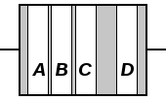](http://en.wikipedia.org/wiki/File:Resistor_bands.svg)[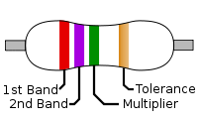](http://en.wikipedia.org/wiki/File:4-Band_Resistor.svg)

|  |  |  |  |  |  |  |
| --- | --- | --- | --- | --- | --- | --- |
| **Color** | **Significant figures** | **Multiplier** | **Tolerance** | | **Temp. Coefficient (ppm/K)** | |
| [Black](http://en.wikipedia.org/wiki/Black) | 0 | ×100 | – | | 250 | U |
| [Brown](http://en.wikipedia.org/wiki/Brown) | 1 | ×101 | ±1% | F | 100 | S |
| [Red](http://en.wikipedia.org/wiki/Red) | 2 | ×102 | ±2% | G | 50 | R |
| [Orange](http://en.wikipedia.org/wiki/Orange_(colour)) | 3 | ×103 | – | | 15 | P |
| [Yellow](http://en.wikipedia.org/wiki/Yellow) | 4 | ×104 | – | | 25 | Q |
| [Green](http://en.wikipedia.org/wiki/Green) | 5 | ×105 | ±0.5% | D | 20 | Z |
| [Blue](http://en.wikipedia.org/wiki/Blue) | 6 | ×106 | ±0.25% | C | 10 | Z |
| [Violet](http://en.wikipedia.org/wiki/Violet_(color)) | 7 | ×107 | ±0.1% | B | 5 | M |
| [Gray](http://en.wikipedia.org/wiki/Grey) | 8 | ×108 | ±0.05% | A | 1 | K |
| [White](http://en.wikipedia.org/wiki/White) | 9 | ×109 | – | | – | |
| [Gold](http://en.wikipedia.org/wiki/Gold_(color)) | – | ×10-1 | ±5% | J | – | |
| [Silver](http://en.wikipedia.org/wiki/Silver_(color)) | – | ×10-2 | ±10% | K | – | |
| None | – | – | ±20% | M | – | |
| 1. Any temperature coefficent not assigned its own letter shall be markd "Z", and the coefficient found in other documentation. 2. For more information, see [EN 60062](http://en.wikipedia.org/wiki/EN_60062). | | | | | | |

Resistor values are always coded in ohms. Band **A** is first significant figure of component value. Band **B** is the second significant figure. Band **C** is the decimal multiplier. Band **D** if present, indicates tolerance of value in percent (no color means 20%).The standard color code per [**EN 60062**](http://en.wikipedia.org/wiki/EN_60062)**:**2005 is as follows:

For example, a resistor with bands of [***yellow, violet, red, and gold***](http://www.okaphone.nl/calc/resistor.shtml?ohm=4700&tol=5)will have first digit 4 (yellow in table below), second digit 7 (violet), followed by 2 (red) zeros: 4,700 ohms. Gold signifies that the tolerance is ±5%, so the real resistance could lie anywhere between 4,465 and 4,935 ohms.

Tight tolerance resistors may have three bands for significant figures rather than two, and/or an additional band indicating [**temperature coefficient**](http://en.wikipedia.org/wiki/Temperature_coefficient), in units of [**ppm**](http://en.wikipedia.org/wiki/Parts_per_million)**/**[**K**](http://en.wikipedia.org/wiki/Kelvin). All coded components will have at least two value bands and a multiplier; other bands are optional.

As an example, let us take a resistor which (read left to right) displays the colors ***yellow, violet, yellow, brown***. We take the first two bands as the value, giving us *4, 7*. Then the third band, another *yellow*, gives us the multiplier 104. Our total value is then *47 x 104 Ω*, totalling *470,000 Ω* or *470 kΩ*. Our brown is then a tolerance of ±1%.

**Breadboard Connections**

